**SAFRIZAL RAHMAN 20_SIB_2G**  
  
**LINK GITHUB : https://github.com/safrizalrahman46/OOP-1_SEMESTER-3.git  
MAAF IBU LAPTOP SAYA RUSAK TIDAK BISA MENJALANKAN VSCODE**

Introduction to Object-Oriented Programming Concepts

# Competence

After taking this experimental material, students are able to get to know and understand the concept of programming with **a structural paradigm (structured programming)**

# Introduction

The fundamental differences between procedural programming and Object Oriented

*Programming (*OOP) are:

* + Structured programming: programs are broken down into sub-programs in the form of **functions**. The characteristics of the object (what it has **and** what it does) are represented in independent (unbound) variables and functions
  + PBO: The program is broken down into **objects**, where the object wraps **attributes** and

### methods.

Here is an example of structural programming:

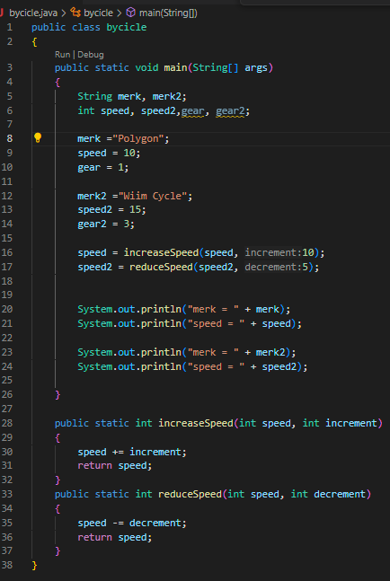public class Bicycle {

public static void main(String[] args) {

String merk1 = "BROMTON";

int speed1 = 10;

int gear1 = 1;

String merk2 = "KOLYGON";

int speed2 = 40;

int gear2 = 1;

speed1 = increaseSpeed(speed1, 30);

speed2 = increaseSpeed(speed2, 120);

System.out.println("Merk sepeda pertama: " + merk1);

System.out.println("Kecepatan sepeda pertama: " + speed1);

System.out.println("Merk sepeda kedua: " + merk2);

System.out.println("Kecepatan sepeda kedua: " + speed2);

}

public static int increaseSpeed(int speed, int increment) {

return speed + increment;

}

}

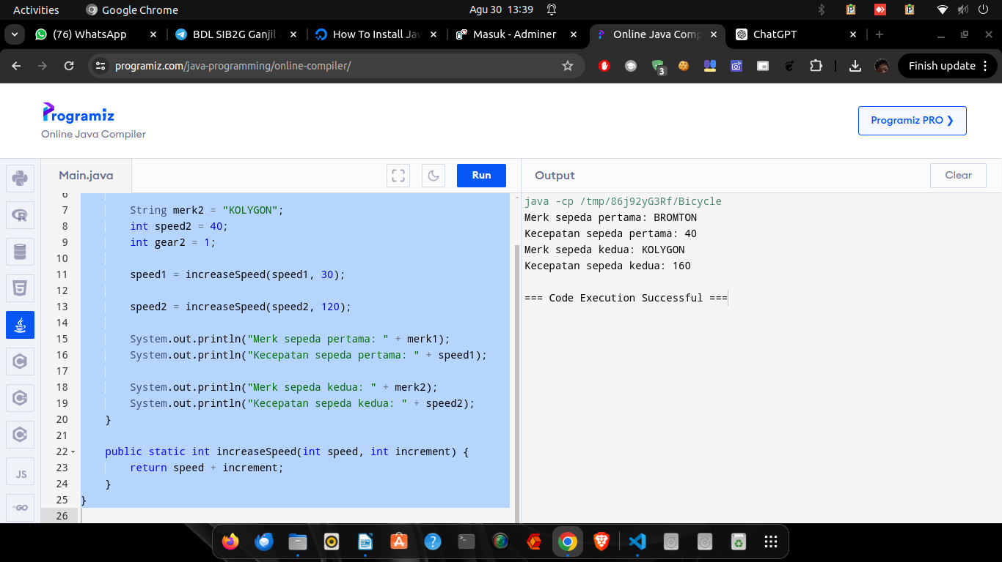

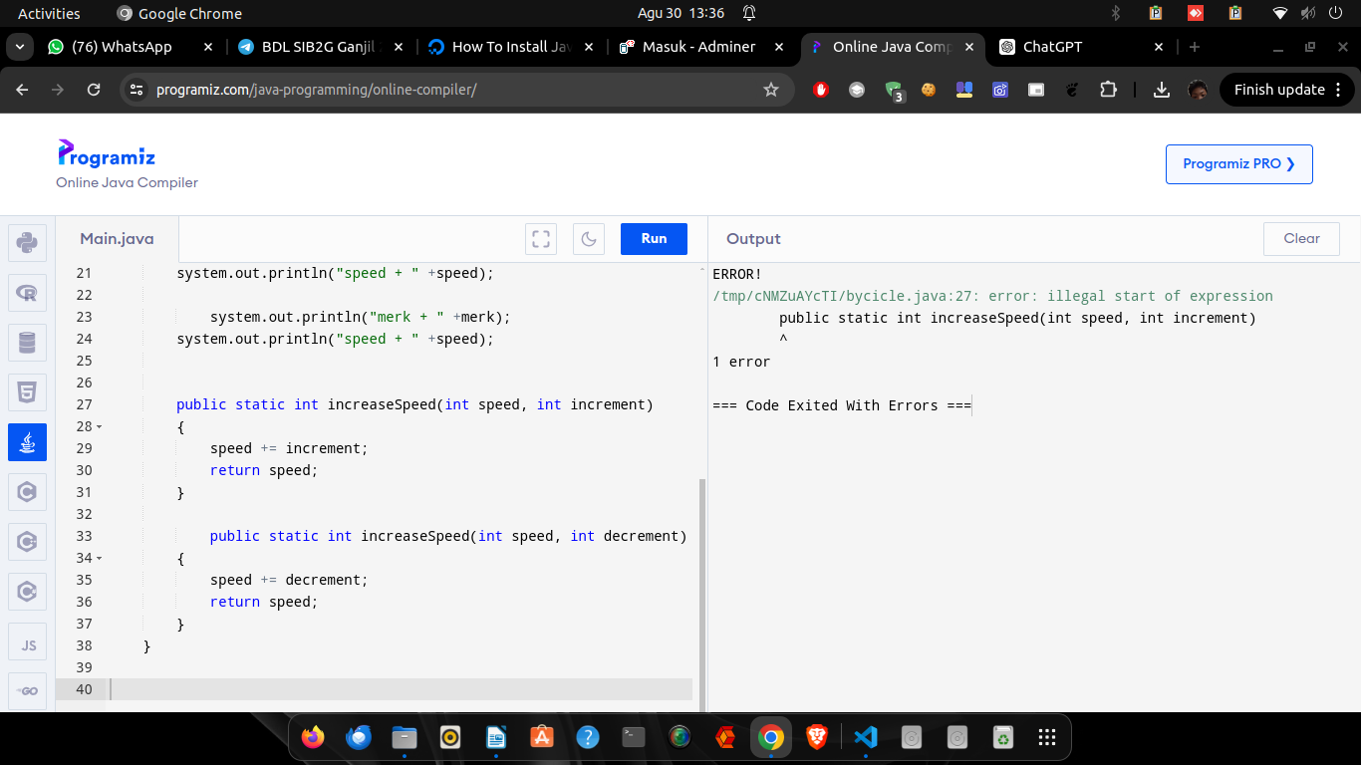

public class bycicle

{

public static void main (String[] args)

{

String merk, merk2;

int speed, speed2, gear, gear2;

merk = "Polygon";

speed = 10;

gear = 1;

merk = "Wiim Cycle";

speed = 10;

gear = 1;

speed = increaseSpeed(speed, 10);

speed2 = increaseSpeed(speed2, 10);

system.out.println("merk + " +merk);

system.out.println("speed + " +speed);

system.out.println("merk + " +merk);

system.out.println("speed + " +speed);

public static int increaseSpeed(int speed, int increment)

{

speed += increment;

return speed;

}

public static int increaseSpeed(int speed, int decrement)

{

speed += decrement;

return speed;

}

}

}

Based on these examples, it can be seen that in the structural programming paradigm:

1. The characteristics/status/values of bicycle objects (things owned by bicycles) in the real world are represented or stored in the program as **independent or unrelated variables**.

The first bike, its characteristics are stored in the variables of merk, speed, and gear

The second bicycle has its characteristics stored in the merk2,speed2, and gear2

If there is a third bike, it will likely be stored in the merk3,speed3, and gear3

In effect, **there is no** mechanism **that guarantees** that the brand variables2, speed2, and gears2 are interconnected

1. The procedure/behavior/process of a bicycle (things that a bicycle can do) in the real world is represented as a function that can be called/executed, i.e. increaseSpeed() and reduceSpeed()

But this method **does not guarantee** that the two functions **can only be called by a bicycle-type object**, it is possible that a seat-type object can call this function.

# Practicum Assignment

## Task 1

Take the following steps so that the practicum assignments carried out are systematic:

1. Define 1 category/class of objects. You can use a new object type or one of the objects from the PBO Theory task. For example: Bicycle
2. Make observations of the object to determine
   * 3 variables/states/traits/states/values that can be had
   * 2 functions/behaviors/procedures/behaviors/processes that the object can perform
3. Implement 10 objects of this type into a program with a **structural programming paradigm** (as in the bicycle example above)
   * Declare and initialize a variable for each characteristic/state/value of an object as a variable
   * Create a function of every procedure/behavior/process that can be performed by the object and then try to call the function/method

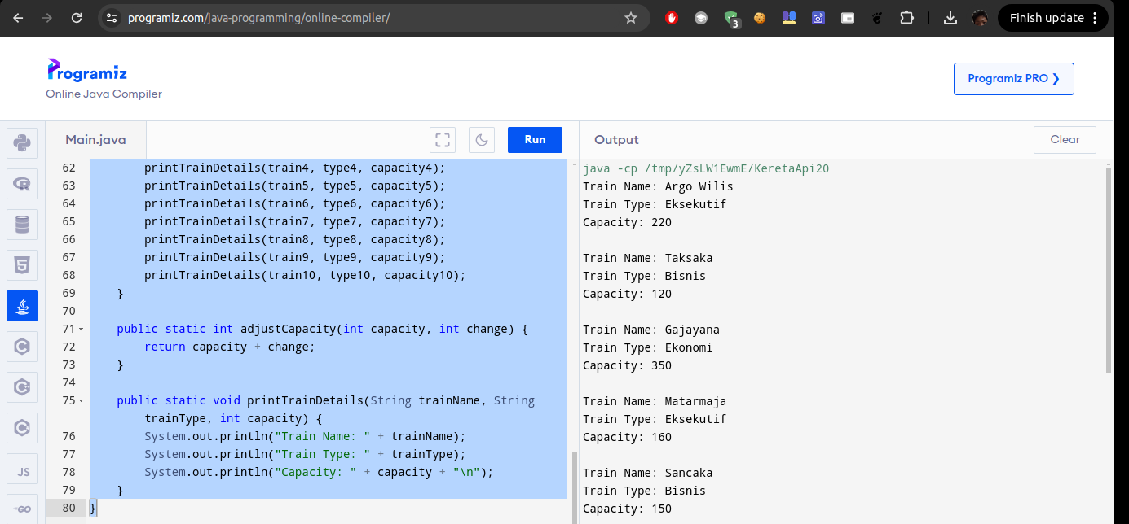

public class KeretaApi {

public static void main(String[] args) {

String train1, train2, train3, train4, train5, train6, train7, train8, train9, train10;

String type1, type2, type3, type4, type5, type6, type7, type8, type9, type10;

int capacity1, capacity2, capacity3, capacity4, capacity5, capacity6, capacity7, capacity8, capacity9, capacity10;

train1 = "Argo Wilis";

type1 = "Eksekutif";

capacity1 = 200;

train2 = "Taksaka";

type2 = "Bisnis";

capacity2 = 150;

train3 = "Gajayana";

type3 = "Ekonomi";

capacity3 = 300;

train4 = "Matarmaja";

type4 = "Eksekutif";

capacity4 = 180;

train5 = "Sancaka";

type5 = "Bisnis";

capacity5 = 140;

train6 = "Lodaya";

type6 = "Ekonomi";

capacity6 = 250;

train7 = "Bangunkarta";

type7 = "Eksekutif";

capacity7 = 200;

train8 = "Bima";

type8 = "Bisnis";

capacity8 = 160;

train9 = "Jayabaya";

type9 = "Ekonomi";

capacity9 = 220;

train10 = "Mutiara Selatan";

type10 = "Eksekutif";

capacity10 = 200;

capacity1 = adjustCapacity(capacity1, 20);

capacity2 = adjustCapacity(capacity2, -30);

capacity3 = adjustCapacity(capacity3, 50);

capacity4 = adjustCapacity(capacity4, -20);

capacity5 = adjustCapacity(capacity5, 10);

capacity6 = adjustCapacity(capacity6, 0);

capacity7 = adjustCapacity(capacity7, -10);

capacity8 = adjustCapacity(capacity8, 15);

capacity9 = adjustCapacity(capacity9, -5);

capacity10 = adjustCapacity(capacity10, 25);

printTrainDetails(train1, type1, capacity1);

printTrainDetails(train2, type2, capacity2);

printTrainDetails(train3, type3, capacity3);

printTrainDetails(train4, type4, capacity4);

printTrainDetails(train5, type5, capacity5);

printTrainDetails(train6, type6, capacity6);

printTrainDetails(train7, type7, capacity7);

printTrainDetails(train8, type8, capacity8);

printTrainDetails(train9, type9, capacity9);

printTrainDetails(train10, type10, capacity10);

}

public static int adjustCapacity(int capacity, int change) {

return capacity + change;

}

public static void printTrainDetails(String trainName, String trainType, int capacity) {

System.out.println("Train Name: " + trainName);

System.out.println("Train Type: " + trainType);

System.out.println("Capacity: " + capacity + "\n");

}

}

## Task 2

Create a simple calculator program with a **structural programming paradigm** that can accept the input of number1, operator, and number2 and display the results to the console/screen

import java.util.Scanner;

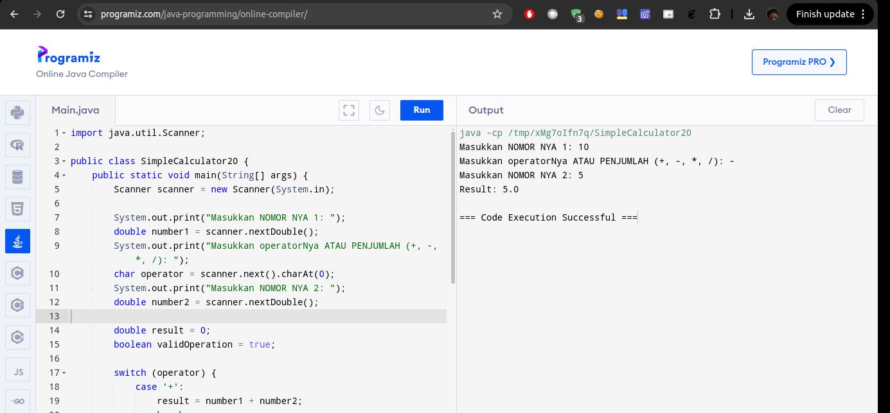

public class SimpleCalculator20 {

public static void main(String[] args) {

Scanner scanner = new Scanner(System.in);

System.out.print("Masukkan NOMOR NYA 1: ");

double number1 = scanner.nextDouble();

System.out.print("Masukkan operatorNya ATAU PENJUMLAH (+, -, *, /): ");

char operator = scanner.next().charAt(0);

System.out.print("Masukkan NOMOR NYA 2: ");

double number2 = scanner.nextDouble();

double result = 0;

boolean validOperation = true;

switch (operator) {

case '+':

result = number1 + number2;

break;

case '-':

result = number1 - number2;

break;

case '*':

result = number1 * number2;

break;

case '/':

if (number2 != 0) {

result = number1 / number2;

} else {

System.out.println("Error: Division by zero.");

validOperation = false;

}

break;

default:

System.out.println("Error: Invalid operator.");

validOperation = false;

}

if (validOperation) {

System.out.println("Result: " + result);

}

}

}

\\\\\\\\\\\\\\\\\\\\

# Question

Write down your analysis, is programming with a structured paradigm suitable for practicum assignments 1 and 2? Explain!

# Direction

1. Work on the Java program code via Netbean or Visual studio Code.
2. Go to the lecturer's desk for an oral test of the results of the practical work assignment (about 5 minutes) after finishing you can go home first or continue working on the report.
3. Report in PDF according to the practical steps and screenshots of the program code, (the original program code for each practical should be kept safe by yourself if the quiz or exam time is asked)
4. Collect the report in LMS in PDF format with a deadline of 23.59 WIB on the same day as the practical, outside of that hour it will not be corrected.

### --- Good Luck----